Notes and Thoughts - Ric's Lunch Hour Talk Re “Executive Presence”

By Ellen Meng

I made a few notes while listening to Ric’s talk re “Executive Presence”. I also blend in some of my thoughts so these notes are not completely random.
About Executive Presence - 8 categories to self-evaluate, and improve
I brought up the “Executive Presence” topic, partly because I was perplexed that such a thing could be used to judge a person’s fitness for a job. I found, after the talk, that Ric has a whole course for “Executive Presence”, so not only is it a thing, it is a very important concept that warrants an entire course!
The checklist is very helpful and practical. Another practical suggestion from Ric was to ask someone to provide you with feedback before doing a presentation or going to a big meeting.
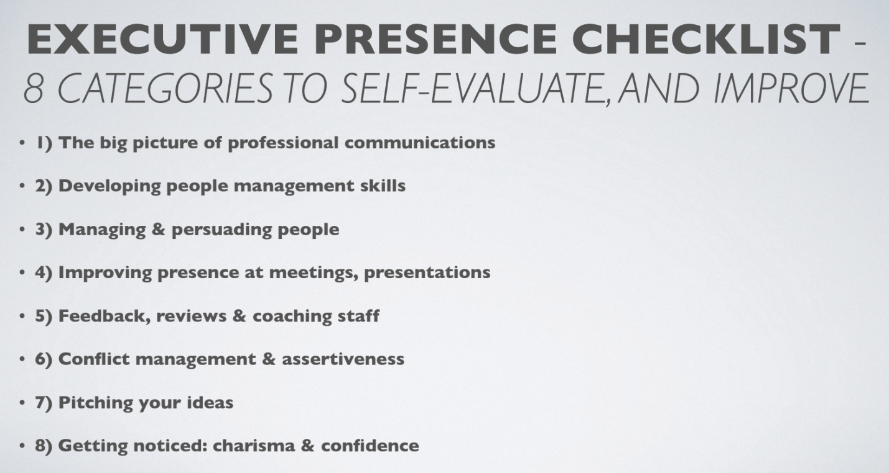
About aggressiveness vs. assertiveness
The issue that new immigrants, or Asians need to learn about being assertive is likely not surprising, but the lack of understanding of what aggressiveness is is even more surprising.
Ric mentioned the following can mean aggressiveness:
- Not allowing others to say ‘no’ (Both my husband and I can think of times we were upset at work and would not allow others to say no.)
- Raising voice
In another seminar, I have also learned holding a fist, pounding a desk, and throwing objects can all be signs of aggressiveness.
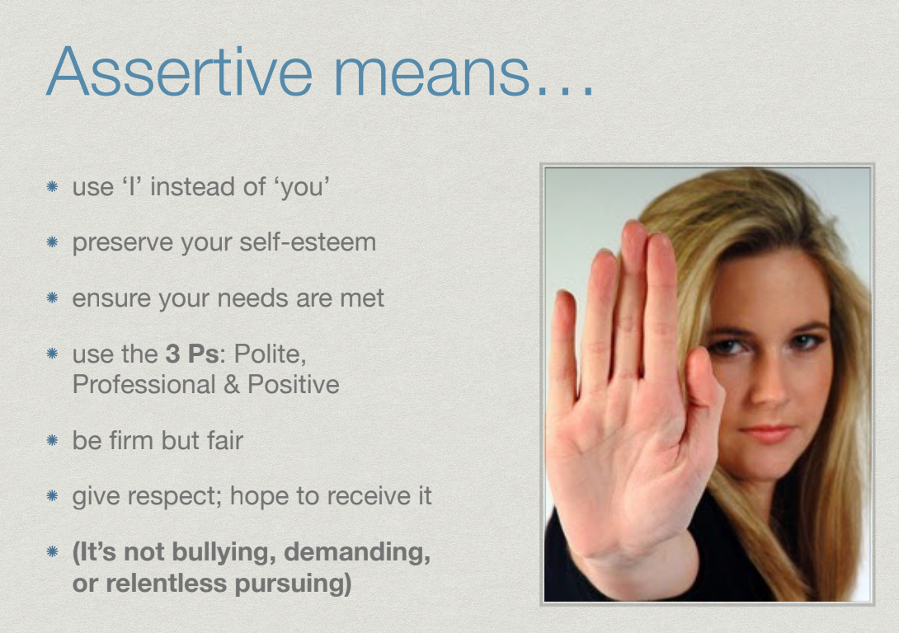
Ric also answered a question to clarify non-offensive/non-aggressive is different from being indirect.
Q: In my work, I often need to review documents. I try to use tactics listed here like using I instead of you, such as “from my perspective, I do not think this is the way…”, but I cannot seem to get my point across.”
Ric: This is more a matter of being direct vs. indirect, rather than aggressive vs. assertive.
I would try anything that can open things up. For example: "I am kind of lost on page 2. Could you tell me your thought process?"

About Removing Personal Judgments
I think this is a hard one for those of us being judged a lot in our life and have formed the same habit under the “influence”. The good news for this one, at least from my personal experience, is that as you get judged less (which is my experience in Canada), you can come out of this habit gradually too.
Here are Ric’s examples and his suggested approaches.
Judgmental | Non-judgemental | Notes
"You're always late" | I have noticed that you are not there. Just wonder what is going on." | Be careful about words like “always”, “never”.
"You can't keep skipping the meetings like they don't matter" | I wonder if you find value in these meetings. I tend to find meaning in these meetings."
"You're not making this a priority" | "Wondering what you think is a priority. I find this a priority. What do you think?"
"You're not listening to me" | "I feel that you are listening, but not sure if you get my point ..." | Be careful not to bring parenting style talking to work, and ideally not talk down to your kids too.

About open to a conversation
Ric also provided a live example about how to give a different opinion yet being direct and respectful. In answering a question regarding being asked “where do you come from?” Ric suggests using this as an opportunity to have a conversation. To support what he suggested, he then also gave his own experience in China, and another example where a candidate was rejected from a job interview because he/she closed on a conversation.

About being “us” instead of “me and you”
I listened to Ric's Tedx Talk The Long Life of First Impressions https://www.youtube.com/watch?v=SuG-BHquAHU and found it really helpful. In the talk, Ric explains three power concepts that are important in forming first impressions, and maybe in any communication: Appreciate, Connect, and Positive. His explanation for “connect” resonates the most with me. “We want to connect as quickly as we can so we are not ‘me and you’ any more, we are ‘us.’” He also went on to explain this helps because we like people like us and we as human beings like that “tribe” feeling. His explanation on verbal vs. non-verbal, on negative also provides insights to the underlying logic for some well known communication rules.
Reflection
It occurred to me, after the talk, that I have been dismissive about the delivery of content while focusing almost solely on the content. This might be partly cultural and partly upbring. We want to be practical and efficient.
I also remember a story my first manager in Canada told me, who is also asian. He said he was in charge of creating a complex report, and transitioned the report to a new person before he left for another job. His replacement did not understand the report or how to update it, so he resolved to make it “really pretty”. Guess what, by making the report pretty, his replacement got way more praises than my manager ever got. My manager felt underappreciated, and I never thought otherwise until today. If my manager learned to appreciate the importance of the style of delivery, would he have opened more doors in his career?

